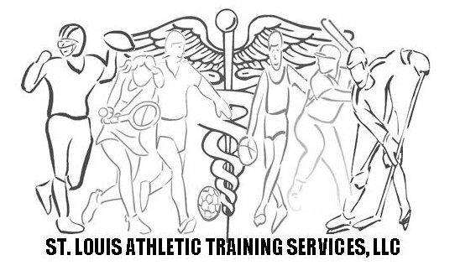
Dear Hockey Parent,
My name is Michael S. Heffner LAT, ATC and I am the owner of St. Louis Athletic Training Services, LLC, a company that provides athletic training services to a variety of athletic teams and leagues. Our priority is to keep young athletes safe and to quickly and effectively assess and treat injuries as soon as they occur.
For a cost of just $40 (based on a 20 player roster) per athlete for the entire season, St. Louis Athletic Training Services, LLS is proposing our services be contracted for every Mid States Hockey game for the 2011-2012 season. St. Louis Athletic Training Services, LLC will provide a certified athletic trainer and all necessary supplies for each contest. We will also provide documentation of all injuries to the parents. If an athlete’s injury requires a physician visit, a copy of our initial evaluation will be provided for physician review.
The price of this proposal is contingent upon every team participating, as each team would share the cost of one certified athletic trainer covering each game. We have provided this service to individual Mid States teams each of the last two years. If this proposal fails with the entire league, we will once again offer our services to individual teams; however the cost for an individual team will change slightly.
Athletic Trainers are licensed healthcare professionals and are the only healthcare professional specifically educated to provide on site sports medicine. Because of the unsupported nature of club sports, your athletes are not provided with the medical protection that virtually all other high school sport programs are given. Most high school athletes are protected with athletic trainers at every game with some sports having physicians and paramedics on site and most programs require that the coaching staff maintain CPR and first aid certification. At this time, there is no requirement for medical personnel at games, nor is there a mandate for CPR or first aid certification for coaches.
If you have questions about the proposal, you can learn more about St. Louis Athletic Training Services, LLC online at www.stlats.com or feel free to contact me.
I look forward to working with your athletes and Mid States!
Sincerely,
Michael S. Heffner ATC, LAT
Owner
St. Louis Athletic Training Services, LLC

www.stlats.com St. Louis Athletic Training Services 19 Tyler Court Wentzville, MO 63385 314-960-3812 www.stlats.com

